CIT26-1002
APPLICATION OF WATER VAPOR AND OXYGEN AS GASIFYING AGENTS IN THE PLASMA GASIFICATION PROCESS FOR THE PRODUCTION OF MOSS HYDROGEN

Marcos Alcino Ribeiro Cussioli
UniMetrocamp University Center – Wyden
marcoscussioli32@gmail.com

Raquel Alves dos Santos
UniMetrocamp University Center – Wyden
raquel.alves568332@gmail.com

Regina Franciélle Silva Paulino
UniMetrocamp University Center – Wyden
regina.paulino@professores.unimetrocamp.edu.br
Laboratory of Optimization of Energy Systems (LOSE), Department of Energy, School of Engineering and Institute of Bioenergy Research (IPBEN-UNESP)-Associated Laboratory of Guaratinguetá, Sao Paulo State University (UNESP) , São Paulo - SP, Brazil.
regina.paulino@unesp.br

Abstract. The climate crisis and the search for carbon-free energy sources have elevated hydrogen to a leading role in the global energy transition. Brazil faces significant problems regarding biomedical waste (BW), which is frequently disposed of inadequately and ends up in septic tanks, dumps, and landfills without any treatment. Plasma gasification technology is very promising as it aims to provide a sustainable disposal method for a range of waste, including biomedical waste. The syngas generated by plasma gasification, rich in CO₂ and H₂, represents the raw material for obtaining high-purity hydrogen. Thus, this work aims to study hydrogen production from moss as a function of the temperature of the plasma gasification process of Brazilian biomedical waste and the gasifying agents, water vapor and oxygen, through simulation in the TERRA software, as well as the electrical energy consumption in the gasifier torches to process 1 kg of BW through thermodynamic equations. In conclusion, the plasma gasification temperature for Brazilian biomedical waste that produces the highest fraction of hydrogen using water vapor and oxygen as gasifying agents is 1020 K and 1070 K, respectively. At these temperatures, mass fractions of hydrogen produced are 5.35% and 4.57%, respectively. It is necessary to use 3558.44 kW and 4296.07 kW of electricity to process 1 kg/s of BW Brazilian at temperatures of 1020 K and 1070 K, respectively.

Keywords: plasma gasification, biomedical waste, hydrogen, , economic analysis.

- Introduction

The Brazilian Association of Public Cleaning and Special Waste Companies (ABREMA), through its Panorama of Solid Waste in Brazil 2025, is the main source of consolidated data for the sector. The study shows that the generation of healthcare waste in the country reached 1.25 million tons in 2024, a volume that, although it represents less than 2% of total municipal solid waste, requires specialized attention due to its hazardous nature. ABREMA (2025) highlights that generation is highly concentrated, with hospital units accounting for 85.9% of the total, followed by clinical analysis laboratories (8.3%), animal health establishments (3.9%), and dental clinics (1.9%).
One of the main logistical and operational challenges, as pointed out by ABREMA (2025), lies in the gravimetric composition and inefficient source segregation. Improper classification causes common waste (Group D) to be treated as infectious waste (Group A), unnecessarily increasing the costs and complexity of handling. Specialized literature supports this limitation, indicating that in hospitals a significant portion (reaching 90% in some case studies) of the waste classified as Group A could be reclassified as Group D if sorting were performed correctly (MADERS; CUNHA, 2015).
Regarding treatment, the ABREMA Panorama (2025) reports that sterilization technologies, such as autoclaving, are the most widely used, treating about 50.1% of infectious waste. Incineration, which enables a drastic volume reduction, accounts for 39.7% of treatment, while microwave treatment reaches 10.2%. The technological choice, however, is a dilemma: incineration raises environmental concerns due to the potential emission of persistent pollutants (dioxins and furans), whereas sterilization does not physically destroy the waste, requiring subsequent final disposal steps. The final stage, and the most critical one for the sector's sustainability, is final disposal. ABREMA (2025) estimates that about 34% of healthcare waste is still sent to inappropriate locations, such as open dumps or controlled landfills, in conflict with the National Solid Waste Policy (PNRS). This scenario shows the urgency of adopting technologies that, in addition to treating biological risk, promote energy recovery and material circularity, such as plasma gasification.
The climate crisis and the search for carbon-free energy vectors have elevated hydrogen (H2) to a leading role in the global energy transition. As a fuel that emits only water vapor during combustion, H2 has the potential to replace fossil fuels in several industrial and transportation sectors. However, the sustainability of the process depends on the production route, particularly green hydrogen, obtained via electrolysis powered by renewable energy or biomass gasification. According to Kuo et al. (2021), the use of plant-based materials or renewable waste to produce H2 contributes directly to the reduction of greenhouse gas (GHG) emissions, in line with global climate objectives. In addition, studies indicate that plasma gasification produces higher hydrogen yields and lower solid waste volumes than conventional techniques, establishing itself as a highly efficient and sustainable solution (OLIVEIRA et al., 2022).
Plasma gasification is a thermochemical conversion process that uses electric plasma to decompose organic waste into synthesis gas (syngas) under a reducing atmosphere. Plasma, an ionized gas at extreme temperatures (1,000 °C to 4,000 °C), completely breaks down complex molecular chains, destroying pathogens and tar while melting inorganic materials into an inert vitrified slag (OLIVEIRA et al., 2022). The process takes place in reactors equipped with plasma torches, where the waste undergoes pyrolysis followed by gasification reactions. The main chemical reactions involved in hydrogen production include steam reforming (C + H2O → CO + H2) and the water-gas shift reaction (CO + H2O → CO2 + H2), both of which are favored by the injection of water vapor into the reactor to maximize H2 yield (FAVAS; TRINDADE; FILLAT, 2017; DIAZ et al., 2015). Messerle, Mosse, and Ustimenko (2018) experimentally demonstrated that plasma gasification of biomedical waste produces a syngas rich in CO and H2 with a high calorific value, outperforming conventional methods in terms of contaminant destruction and conversion efficiency.
Gasification is defined as a method in which the molecules of the feedstock are decomposed into their constituent elements at high temperatures and under atmospheric or elevated pressures. The process must be carried out in the presence of a gasifying agent, such as steam, air, O2, CO2, or even mixtures of these agents (OLIVEIRA et al., 2022).
Water vapor is the most efficient agent for maximizing hydrogen production. Steam favors the water-gas shift reaction, which consumes carbon monoxide and water to produce more hydrogen and carbon dioxide. The use of steam in plasma reactors can increase the hydrogen concentration to ranges between 40% and 60% in the dry gas (CVETINOVIĆ et al., 2025). Oxygen mainly promotes partial oxidation reactions, which are exothermic and supply heat to the process. Although it increases the overall thermal efficiency, oxygen alone tends to produce a gas richer in carbon monoxide than in hydrogen when compared with steam (SIKARWAR et al., 2020).
Given the high generation of healthcare service waste (HSW) and the possibility of using the plasma gasification process to contribute to its final disposal in a more efficient and safer way, this study aims to evaluate the use of water vapor and oxygen as gasifying agents in the HSW plasma gasification system through simulation in the TERRA software, in relation to the hydrogen fraction produced, and to determine the energy required in the plasma torch for the use of the respective gasifying agents to process 1 kg/s of HSW.

- MATERIAL

For the development of this work, Brazilian hospital solid waste with the elemental composition shown in Table 1 was used.

Table 1 – Elemental composition of Brazilian biomedical waste (%) (PAULINO et al., 2022)
Componentes | Hospital | Enfermaria | Centro Cirúrgico | Outros | Média | Desvio padrão
C | 35,73 | 30,80 | 27,90 | 32,00 | 31,6 | 1,6
H | 3,87 | 3,60 | 3,90 | 3,60 | 3,74 | 0,08
S | 0,00 | 0,00 | 0,50 | 0,30 | 0,20 | 0,12
Cl | 0,32 | 0,08 | 0,09 | 0,09 | 0,15 | 0,06
N | 0,51 | 0,50 | 0,38 | 0,64 | 0,51 | 0,05
O | 37,40 | 36,72 | 28,13 | 47,07 | 37,3 | 3,9
H2O | 18,33 | 24,10 | 28,60 | 12,20 | 20,8 | 3,6
Cinzas | 9,03 | 4,20 | 10,50 | 4,10 | 7,0 | 1,7

- METHODOLOGY

There are two commonly used methods for calculating the composition of a thermodynamic equilibrium system. The first method is based on the law of conservation of mass and uses equilibrium constants. In this case, the path followed by the process is irrelevant; only the initial and final states of the system matter. Chemical transformations are represented as reversible reactions of dissociation of substances into elements. The second method for calculating equilibrium composition is based on the search for maximum entropy or minimum Gibbs energy. In this case, a thermodynamic system is considered as a set of individual substances without considering chemical reactions. The extreme values of the characteristic functions (entropy or Gibbs energy) are determined for all phases. In this case, the laws of mass conservation, charge conservation (for plasma), and the equation of state must be considered. Thus, the extreme of the characteristic functions is found and the composition of the system is obtained by applying the method of undetermined Lagrange multipliers. After building the Lagrange function and taking the partial derivatives with respect to all variables, a system of equations is obtained that can be solved by the method of successive approximations. This method was applied in this study using simulation in the TERRA software.
To simulate the gasification process under thermodynamic equilibrium, the average values of the feedstock (HSW) elements were used, with temperature varied from 300 to 1400 K at atmospheric pressure. This temperature range was selected because at higher temperatures the syngas energy yield decreases.
To determine the energy required in the torch using the different gasifying agents (water vapor and oxygen) to process 1 kg/s of healthcare service waste, Equation (1) was used (PAULINO et al., 2024).

$E_{tocha}=\frac{{\overset{˙}{m}}_{RSS}.∆H}{η_{tocha}}$ (1)

Onde:
$E_{tocha}:$ electrical power of the torch [kW];
${\overset{˙}{m}}_{RSS}:$ mass flow rate of HSW [kg/s];
$∆H:$ enthalpy difference [kJ/kg], i.e., the energy required to heat 1 kg of HSW from the initial to the final state.
The thermal efficiency of the plasma torch, η_plasma, for converting electrical energy into thermal energy depends on the design and type of plasma torch. The average thermal efficiency of a non-transferred arc plasma torch is 70%. Such a torch requires a relatively high plasma gas flow rate, which is also necessary to stabilize the electric arc and is suitable for supplying oxidant (or another reactive gas) to the gasifier. By contrast, the transferred arc plasma torch has a thermal efficiency of 95% and requires a very small gas flow. Such torches are more suitable for the plasma gasification process (TIWARI et al., 2019). In this study, a transferred arc torch was considered. The transferred arc torch requires a conductive medium or an external electrode to close the electrical circuit.

- RESULTS

Figure 1 – Concentrations of CO, H2 and C(s) as a function of temperature

Source: Prepared by the author (2026).

Figure 2 – Variation of C(s) as a function of temperature with water vapor and oxygen
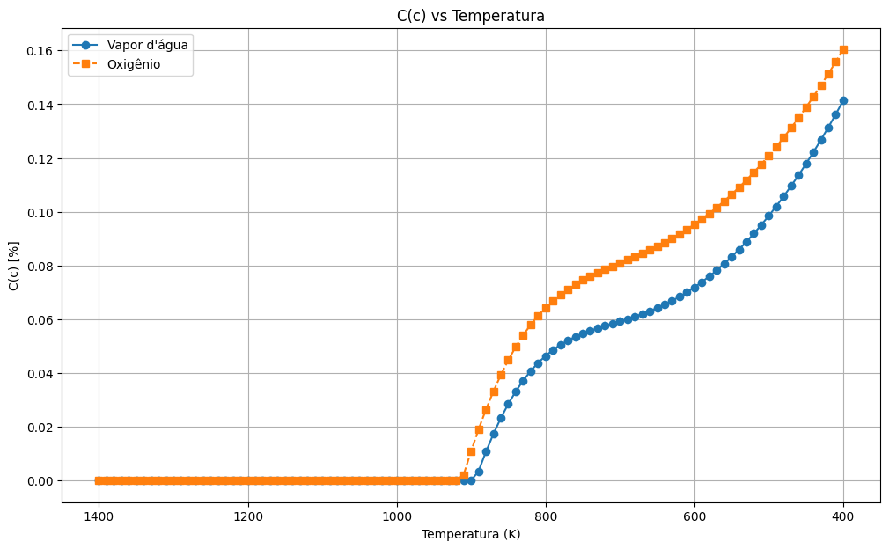

Source: Prepared by the author (2026).

Figure 3 – Variation of H2 as a function of temperature with water vapor and oxygen
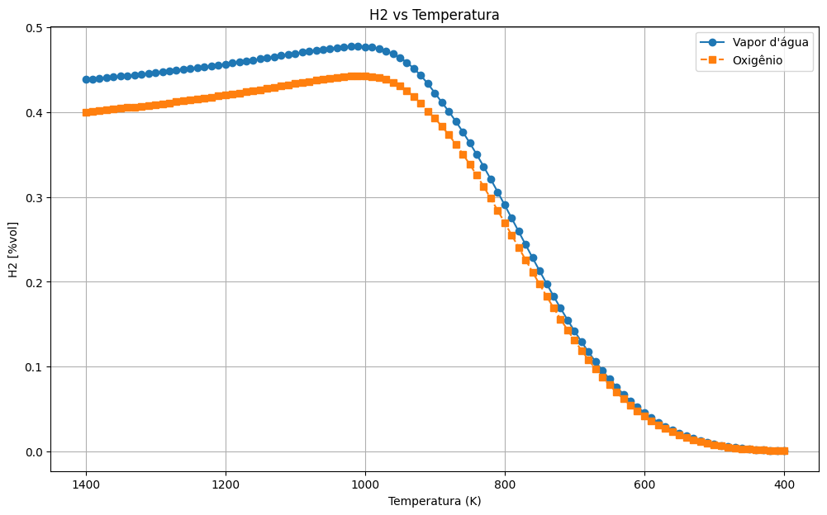

Source: Prepared by the author (2026).

Figure 4 – Simultaneous variation of C(s), H2 and CO as a function of temperature with water vapor and oxygen
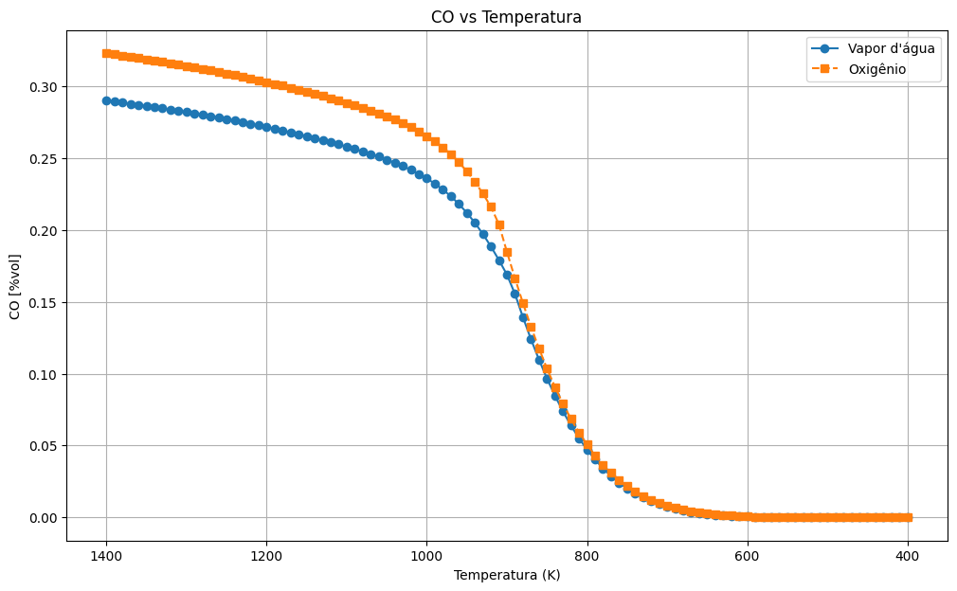

Source: Prepared by the author (2026).

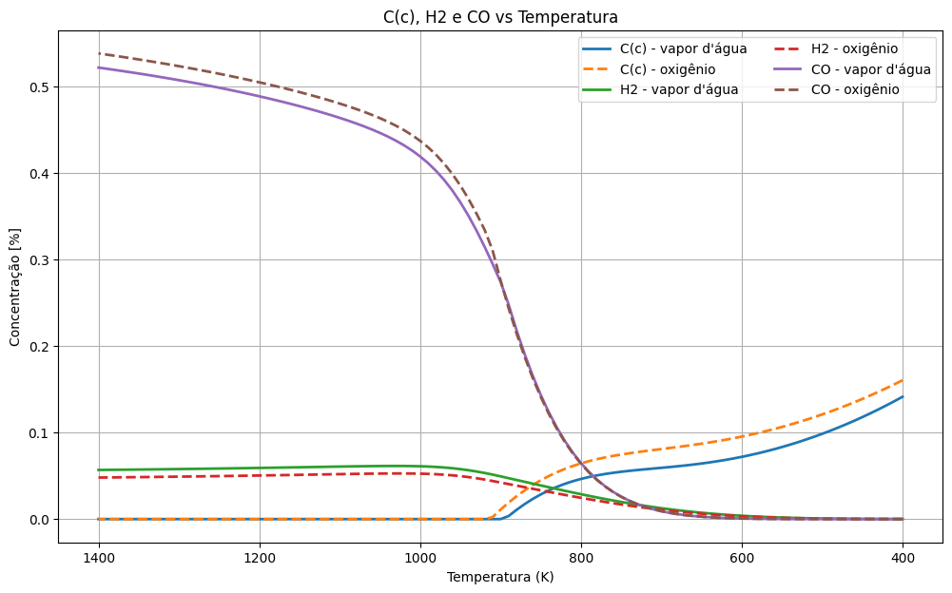

Figure 5 – Energy required in the plasma torch as a function of temperature for water vapor and oxygen as gasifying agents
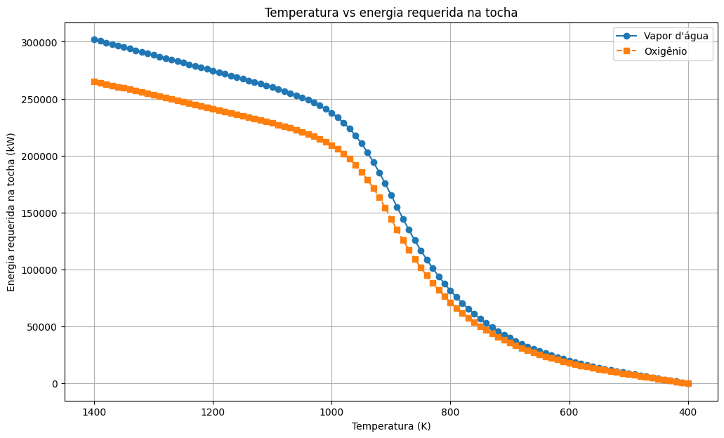

Source: Prepared by the author (2026).

The thermodynamic simulation of the plasma gasification process, performed in the TERRA software over the 300 to 1400 K range, showed behavior dependent on the gasifying agent. An increase in the hydrogen fraction was observed with rising temperature up to a maximum region, followed by a reduction at higher temperatures, whereas carbon monoxide exhibited the opposite trend and solid carbon C(s) was progressively consumed during heating.
With water vapor as the gasifying agent, the temperature that produced the highest hydrogen fraction was 1020 K, with 5.35% H2. For oxygen, the highest value was obtained at 1070 K, with 4.57% H2. These results indicate superior performance of water vapor compared with oxygen in hydrogen generation under the evaluated conditions.
The estimated electrical power required to process 1 kg/s of healthcare service waste was 3558.44 kW for the water vapor condition and 4296.07 kW for the oxygen condition. Therefore, the use of water vapor resulted in lower energy demand and a higher hydrogen fraction than oxygen.

- Conclusions
It is concluded that, under the simulated conditions, water vapor presented better performance as a gasifying agent for hydrogen production in the plasma gasification process of healthcare service waste. The temperature of 1020 K provided the highest H2 fraction among the evaluated conditions, outperforming the result obtained with oxygen.
It is also concluded that operation with water vapor required lower electrical power from the plasma torch than operation with oxygen, reinforcing its greater suitability for the analyzed scenario. Thus, based exclusively on the simulated data, water vapor proved to be the most favorable alternative for maximizing hydrogen production and reducing the energy required in the process.

- Acknowledgements

This publication was funded by IBMEC EDUCACIONAL LTDA and UNIMETROCAMP WYDEN.

- References

ABREMA (2026). Brazilian Association of Waste and Environment. Panorama of Solid Waste in Brazil 2023 (Internet). 2026. Available at: https://www.abrema.org.br/wp-content/uploads/dlm_uploads/2024/03/Panorama_2023_P1.pdf. Accessed on: 04/12/2024.
Cvetinović, D.; Aleksandar Erić; Slobodan Cvetković; Mirko Komatina; Nebojša Manić; Bojan Janković. Performance assessment and techno-economic analysis of the thermal plasma gasification of biomass using air and steam as gasification medium. Applied Thermal Engineering, v. 276, 2025, 126940. https://doi.org/10.1016/j.applthermaleng.2025.126940.
FAVAS, J. M. S.; TRINDADE, T.; FILLAT, M. Hydrogen production using plasma gasification with steam injection. International Journal of Hydrogen Energy, v. 42, n. 33, p. 21017–21031, 2017.
KUO, P.-C.; ILLATHUKANDY, B.; WU, W.; YANG, T.-S.; HSIEH, C.-C.; HWANG, W.-S.; CHEN, W.-H.; WU, J.-D.; CHEN, S.-L. Experimental evaluation and 3E analysis of hydrogen production via plasma gasification of microalgae. Energy, v. 223, p. 120025, 2021.
MADERS, G. R.; CUNHA, H. F. A. Analysis of the management and handling of healthcare service waste (HSW) from the Emergency Hospital of Macapá, Amapá, Brazil. Engenharia Sanitária e Ambiental, v. 20, n. 4, p. 601–610, 2015.
MESSERLE, V. E.; MOSSE, A. L.; USTIMENKO, A. B. Processing of biomedical waste in a plasma gasifier. Waste Management, v. 79, p. 791–799, 2018.
Oliveira, M.; Ramos, A.; Ismail, T. M.; Monteiro, E.; Rouboa, A. A review on plasma gasification of solid residues: recent advances and developments. Energies, 2022, 15, 1475. https://doi.org/10.3390/en15041475.
SIKARWAR, V. S. et al. Plasma gasification as a potential solution for waste-to-fuels applications. Journal of Cleaner Production, Elsevier, v. 277, p. 123985, 2020.
Paulino, R. F. S.; Essiptchouk, A. M.; Costa, L. P. C.; Silveira, J. L. Thermodynamic analysis of biomedical waste plasma gasification. Energy, v. 244, p. 122600, 2022.
Tamošiūnas, A.; Gimžauskaitė, D.; Aikas, M. et al. Biomass gasification to syngas in thermal water vapor arc discharge plasma. Biomass Conversion and Biorefinery, v. 13, p. 16373–16384, 2023. https://doi.org/10.1007/s13399-023-03828-3.

- Responsibility notice

The authors are responsible for the printed material included in this paper.

